Results of Descriptive Statistics:

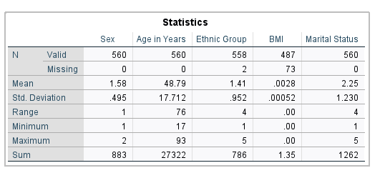

The table above shows a summary of four variables of pinkland0 (8) dataset (Sex, Age, Ethnic Group and Marital Status). We can conclude that, the dataset contains people of up to the age of 93 at maximum and 17 at minimum however most people are old as the range of 76 states.

pie chart distribution above shows that largest portion of pinkland0 (8) dataset contains the white group of people and the smallest portion of pinkland0 (8) dataset is represented by other group of people.

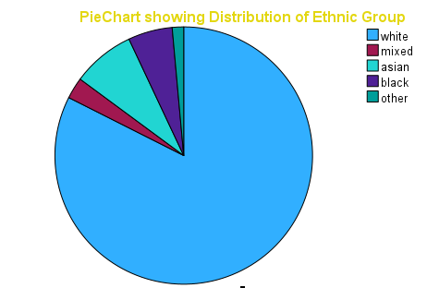

The pie chart distribution above shows that largest portion of pinkland0 (8) dataset contains the white group of people and the smallest portion of pinkland0 (8) dataset is represented by other group of people.

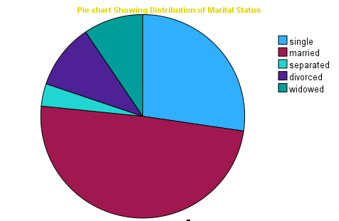

The pie chart distribution above shows that largest portion of pinkland0 (8) dataset contains married people and the smallest portion of pinkland0 (8) dataset represents separated group of people

Results of Inferential statistics and analytical epidemiology

For this analysis, we will use BMI as a continuous variable, age as a continuous variable, and educational attainment as categorical variable with fewer categories. To investigate the association between BMI and age, sex, and educational attainment, we will use inferential statistics. Specifically, we will use a multiple linear regression analysis to determine the relationship between BMI and age, sex, and educational attainment. The multiple linear regression will allow us to determine the strength of the association between BMI and each of the other variables, as well as the overall contribution of the variables to the overall model. This would help to identify if there is a statistically significant association between BMI and the other variables.

Hypotheses Results

The study seeks to investigate the effect sex, age, and educational attainment on BMI. Following hypotheses were proposed.

H_{1} There is a significantly positive impact of sex on BMI

H_{2} There is a significantly positive impact of age on BMI

H_{3} There is a significantly positive impact of educational attainment on BMI

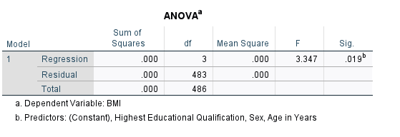

The dependent variable (BMI) was regressed on predicting variables of sex, age, and educational attainment. The independent variables significantly predict BMI, F(3, 483) = 3.347, p > 0.001 which indicates that the three factors under study have no significant impact on BMI. Moreover, the R ^ 2 = 0.020 depicts that the model explains 2.0% of the variance in BMI.

Additionally, coefficients were further assessed to ascertain the influence of each of the factors on the criterion variable (BMI).

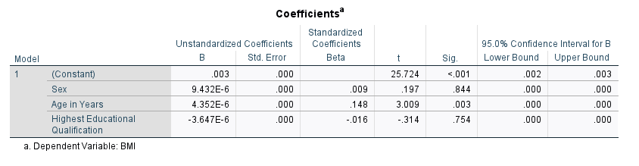

Hi evaluates whether sex significantly and positively affects BMI. The results revealed that there is no significant positive impact on BMI (B = 0.009, t = 0.197, p = 0.844 . Hence, Hi was Not supported. H2 evaluates whether age has a significantly positive impact BMI. The results show that there is no significant positive impact on BMI (B = 0.148, t = 3.009, p = 0.003) Consequently, H2 was Not supported. H3 evaluates whether educational attainment has a significantly positive impact on BMI. The results show that educational attainment there is no significant positive impact on BMI (B = -0.016 , t = -0.314 , p = 0.754 ) . Hence, H3 was Not supported. The results are presented in Table 1.